File permission task

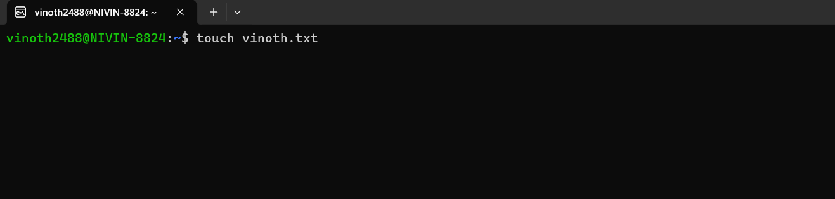

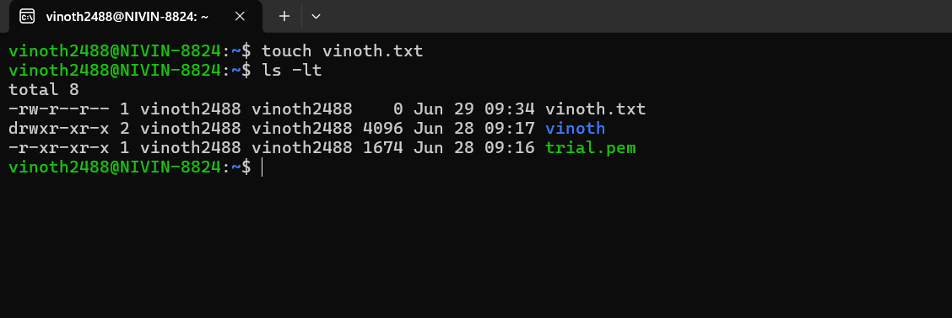

Command: chmod 764 vinoth.txt

